**How to Use Pair Plot for Predictive Modeling Decisions**

Before building any machine learning model, one powerful step I always take is **visualizing the relationships between features** using a **Pair Plot**.

As part of my project on **Agricultural Product Demand and Revenue Forecasting**, I used sns.pairplot() to explore the interactions between key numeric variables like:

🔹 Revenue  
🔹 Quantity_Sold  
🔹 Quality_Score

...with **Product Category** as the hue. Here's how this shaped my predictive modeling path 👇

**🔍 How Pair Plot Guided My Modeling Decisions**

1. 🧠 **Understand Feature Relationships**
   * The pair plot revealed a **strong relationship** between Quantity_Sold and Revenue.
   * ➤ I decided to **avoid including both** as independent features in the same model to reduce multicollinearity.
   * ➤ Instead, I used Quantity_Sold to predict Revenue — shifting the modeling direction.
2. 🧩 **Detect Non-Linear Patterns**
   * Patterns weren’t always linear — especially between Quality_Score and Revenue.
   * ➤ This prompted the use of **tree-based models** like **XGBoost** and **Random Forest**, which handle non-linearity better than linear regression.
3. 🎯 **Refine Feature Engineering Strategy**
   * Quality_Score showed a **bimodal distribution**, implying different product tiers.
   * ➤ I considered **categorizing quality scores** or using them to create product-type-specific models.
4. 🧪 **Select Suitable Model Types**
   * When relationships are:
     + **Linear** ➤ Go for **Linear Regression**, **Ridge**, or **Lasso**.
     + **Non-linear** ➤ Use **XGBoost**, **Random Forest**, or **SVM**.
     + **Clustered by Category** ➤ Consider **individual models per category** or **classification pipelines**.

**🚀 Takeaway**

A **pair plot is more than a visual tool**—it's a **strategic diagnostic instrument** for: ✅ Identifying relationships  
✅ Reducing feature redundancy  
✅ Spotting distribution patterns  
✅ Guiding model selection  
✅ Enhancing feature engineering

🔧 **Tools Used**: Python | Seaborn | Scikit-learn | XGBoost  
📊 **Focus**: Revenue Forecasting | Product Demand Prediction

This analysis is part of my journey with the #Amdari21DaysDataChallenge, showcasing how **exploratory visualizations** can power **smart modeling decisions**.

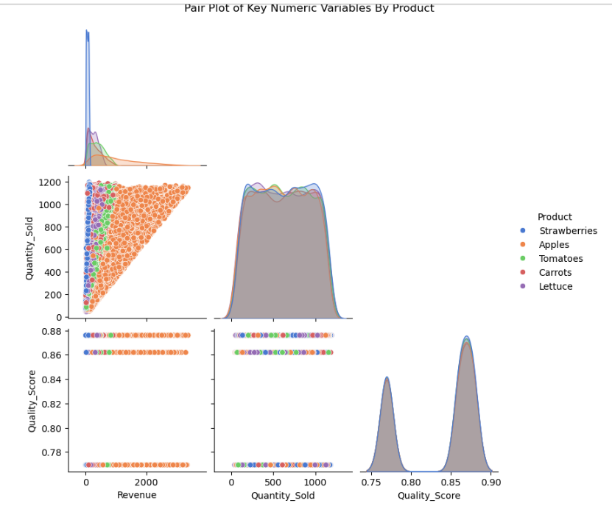

💬 How do you use pair plots to influence your predictive modeling?

#PredictiveModeling #PairPlot #DataVisualization #ExploratoryDataAnalysis #XGBoost #FeatureEngineering #DataScience #MachineLearning #AgriTech #Forecasting #EDA #Python #Seaborn